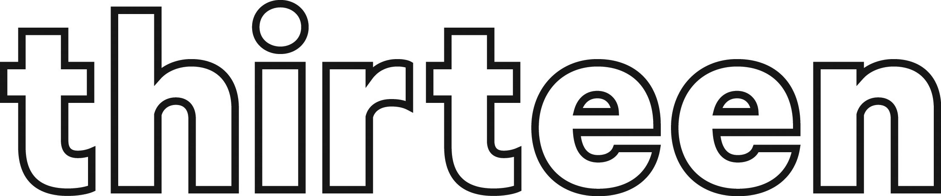

At Thirteen, we aspire to have an inclusive working culture and embrace diversity across the Group.

We’re more than just a landlord. We believe everyone is an individual. We have a responsibility to promote inclusivity for everyone, and particularly people from underrepresented or marginalised groups.

We would be grateful if you would complete the below. The questions are aligned with the government census data so Thirteen’s Talent team can compare applications to the communities we serve.

Please be reassured that all information will be treated in confidence. Your responses will not be shared with recruiting managers. There is no obligation on you to provide information – you can choose the options ‘prefer not to say’.

Please complete the form by selecting one option for each question unless otherwise stated.

1. Ethnic Origin

☐ Any other Asian background
☐ Any other Black, Black British, Caribbean or African background
☐ Any other ethnic group
☐ Any other Mixed or Multiple ethnic background
☐ Any other White background
☐ Arab
☐ Asian or Asian British – Bangladeshi
☐ Asian or Asian British – Chinese
☐ Asian or Asian British – Indian
☐ Asian or Asian British – Pakistani
☐ Black or Black British – African
☐ Black or Black British – Caribbean
☐ Prefer not to say
☐ Roma
☐ White English, Scottish, Welsh, Northern Irish or British
☐ White Gypsy or Irish Traveller
☐ White Irish
☐ White and Asian
☐ White and Black African
☐ White and Black Caribbean

2. Which of the following best describes your gender?

☐ Female (including transgender woman)
☐ Male (including transgender man)
☐ Prefer not to say
☐ Prefer to self-describe as: __________________________

3. Is your gender identity different from the one you were assigned at birth?

☐ Yes
☐ No
☐ Prefer not to say

4. Sexual Orientation

☐ Asexual
☐ Bisexual
☐ Gay or Lesbian
☐ Heterosexual / Straight
☐ Prefer not to say

5. Religion or Belief

☐ Atheist
☐ Buddhism
☐ Christianity
☐ Hinduism
☐ Islam
☐ Judaism
☐ No religion
☐ Other: __________________________
☐ Prefer not to say
☐ Sikhism

6. Do you consider yourself to have a long-term physical or mental health condition (12 months or more)?

☐ Yes
☐ No
☐ Prefer not to say

7. Do you have any conditions or illnesses which substantially impact your ability to carry out day-to-day activities?

☐ Yes, a lot
☐ Yes, a little
☐ Not at all
☐ Prefer not to say

8. Do you consider yourself to be neurodivergent (e.g. Autism, ADHD)?

☐ Yes
☐ No
☐ Prefer not to say

9. Marital Status

☐ Civil Partnership
☐ Co-habiting
☐ Divorced
☐ Living with partner
☐ Married
☐ Prefer not to say
☐ Separated
☐ Single
☐ Widowed

10. Age Range

☐ 16–24 years
☐ 25–34 years
☐ 35–44 years
☐ 45–54 years
☐ 55–64 years
☐ 65+ years
☐ Prefer not to say

ends

